Workshop: SQL Online Music Store
Beatriz Moreira
DAB NOV 2025
Jan 13, 2026

Question 1:
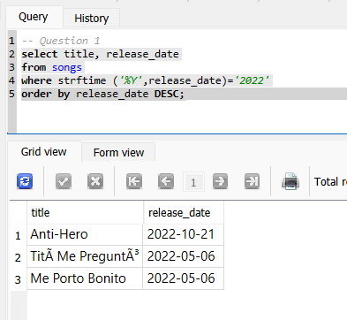
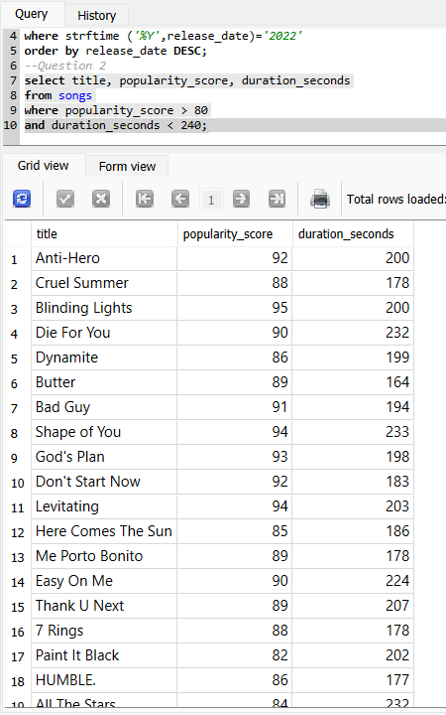
Question 2:
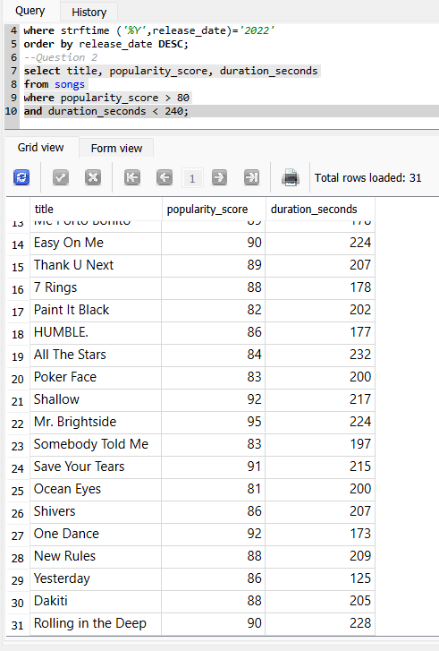

Question 3:
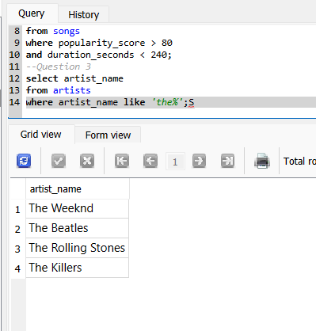

Question 4:
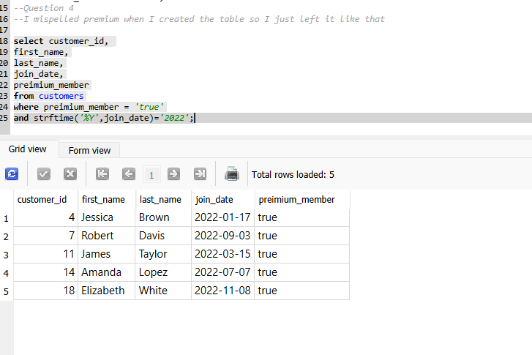
question 5:
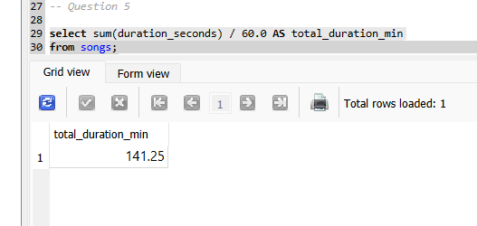

Question 6:
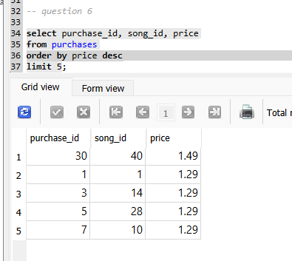

Question 7:
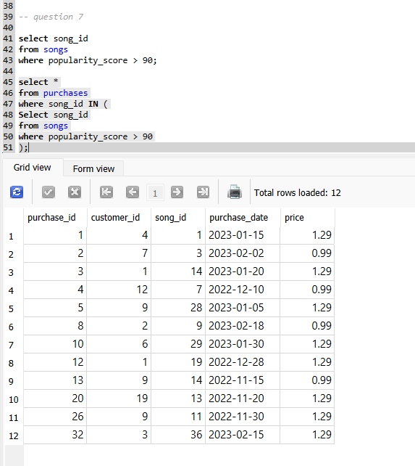

Question 8:
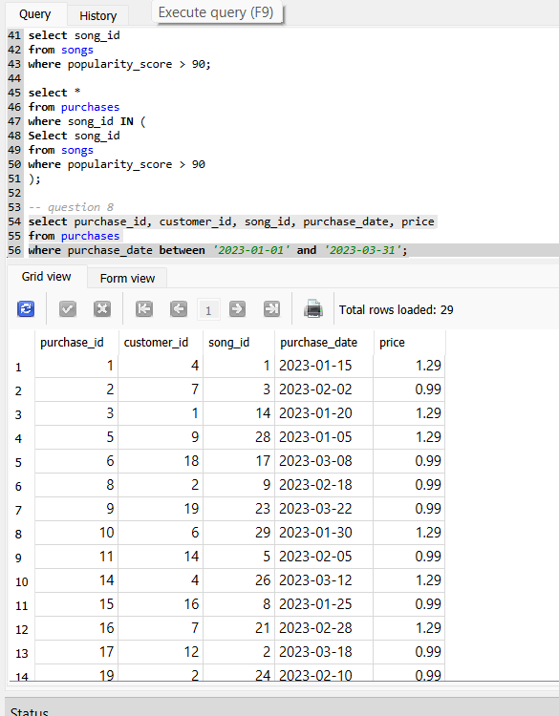

Question 9:
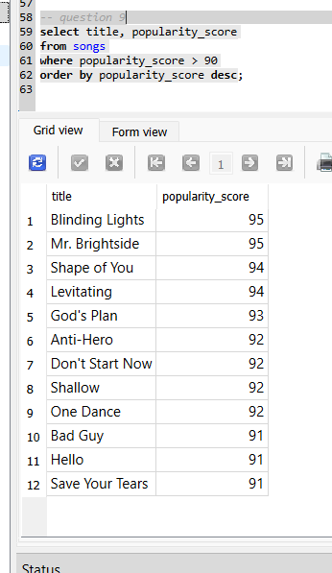

Discussion questions:
- Purchases and streams are different types of actions. When someone purchases the information is amount, and purchase date. For streaming, the information/data is when they listened and how often, with no price associated. If they’re in the same table, we would end up with a lot of empty fields in either ‘table’ – this makes the data hard to work with. Keeping them separate makes them easier to analyze and it’s cleaner.
- They could see which artists make the most money, how often songs are streamed vs bought. They could also take a look at what premium members buy and stream, and if that changes at all with time of year or events.
- The data schema could add how many seconds someone listened to a song and then whether or not the song was skipped or completed. If additional data were collected and added to the streams table this could be included, or there could be a specific listening_events table that collects this data. Some of the potential adds could be: listened_seconds, skip_flag, complete_flag. That way data could be analyzed to see if there are any patterns on completion or when a particular song is usually skipped at a particular time, or an artists song tends to be skipped or completed more.
- I would combine the filters from the earlier questions into one query that joins the songs and artists. The query would return songs released in 2022 that have a popularity score above 80, duration under 4 minutes, and are performed by artists that begin with “The”. This would result in a list of popular short songs from a specific group of artists. Something like:

